**Quiz Question**

TRUE or FALSE: Agile emerged organically as a result of a market need to deal with the crisis product development faced in the 1990s because it was taking somewhere in the range of 2-4 years to get a software solution to production from the time it was conceived as a valuable business need.

True

TRUE or FALSE: Agile enables organizations to deliver additional value through Business Agility. True

Which of the following statements is true about Agile?

[Select all that apply]

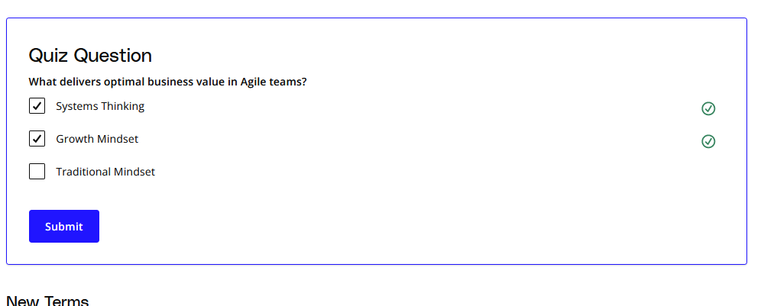

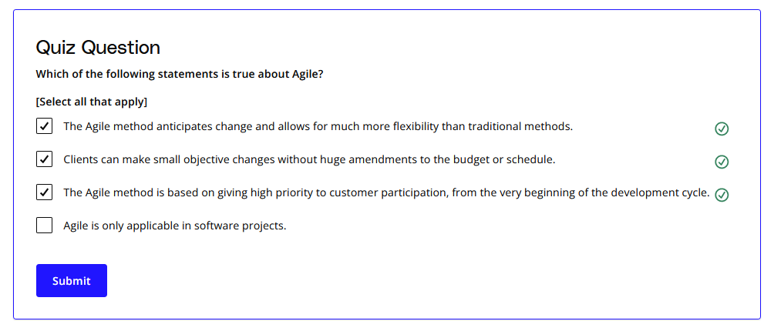

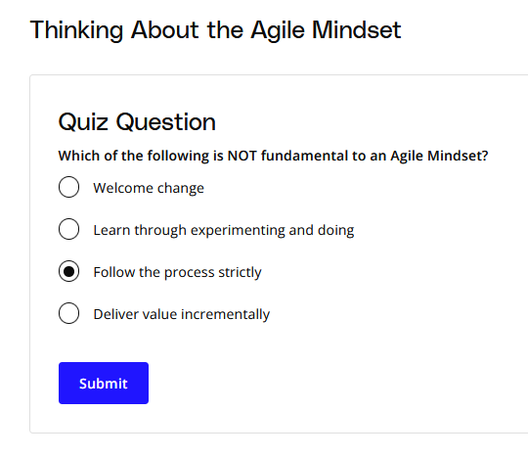

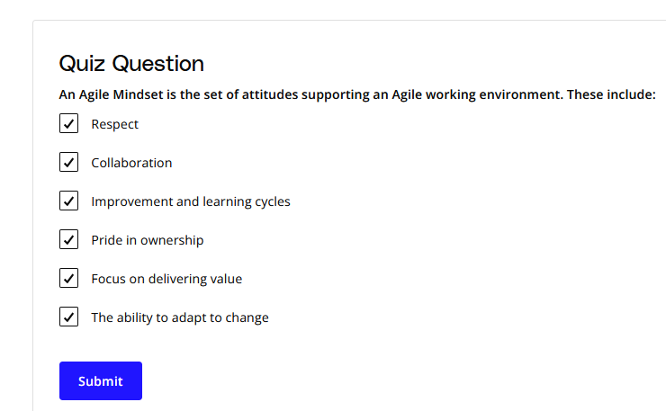

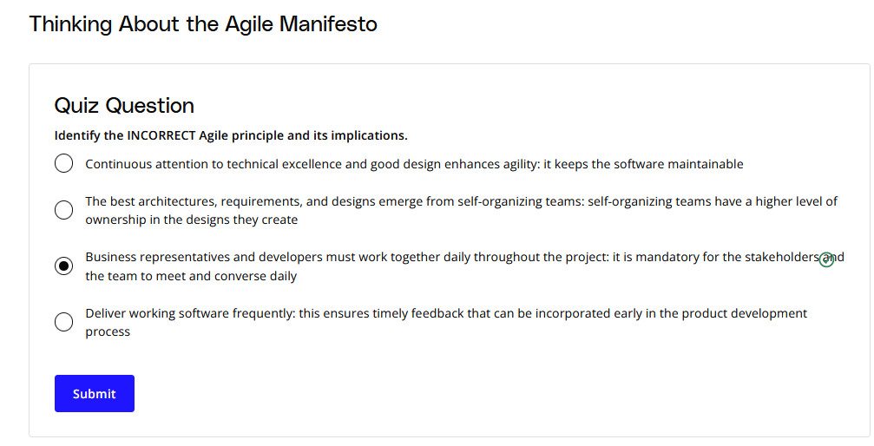

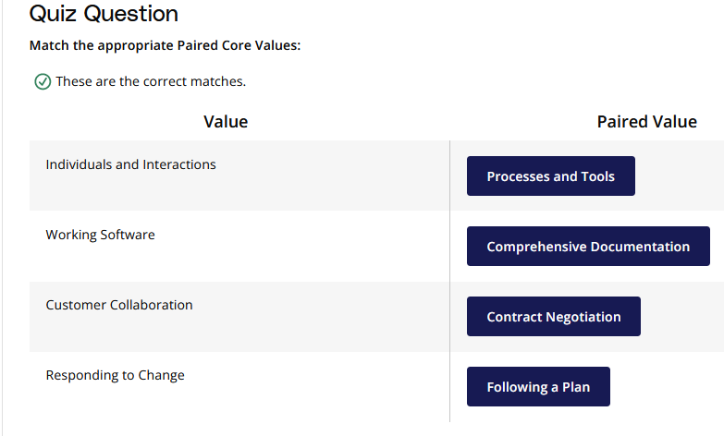

TRUE or FALSE: It no longer makes sense for an organization to use the Waterfall Methodology to run projects. fALSE

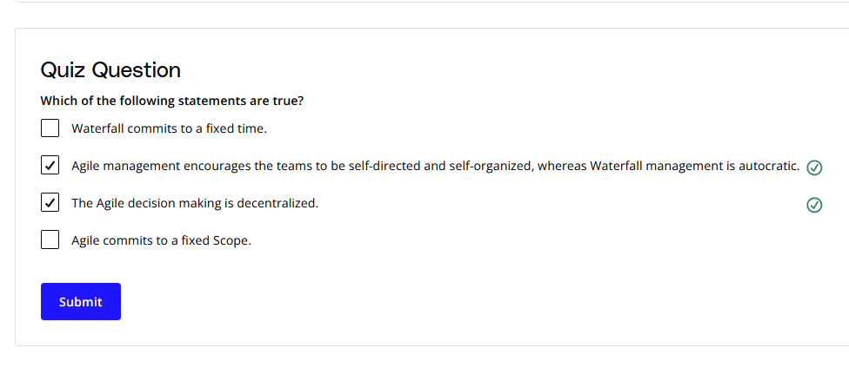

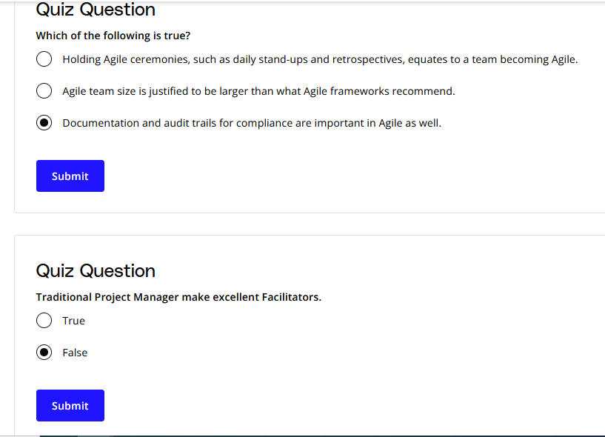

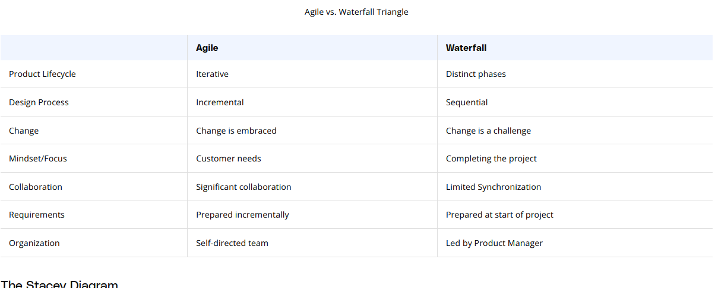

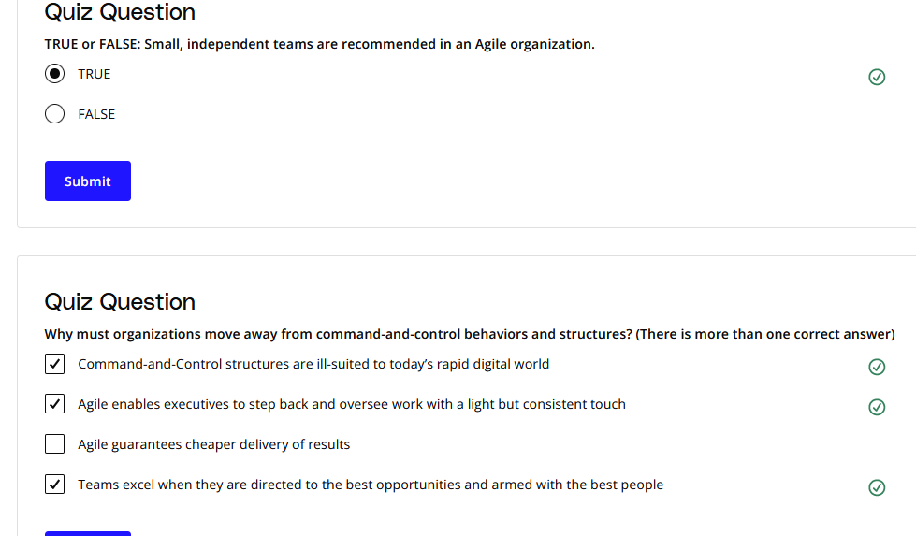

TRUE or FALSE: The **Facilitator** represents the Voice of the Customer (VOC) FALSE

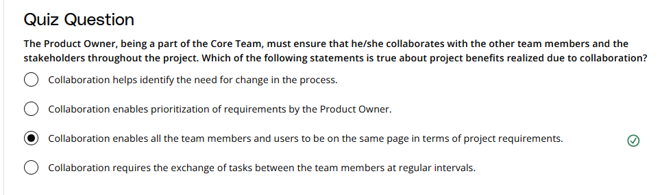

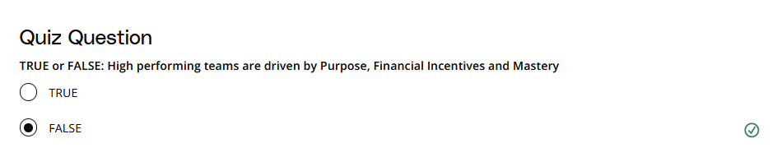

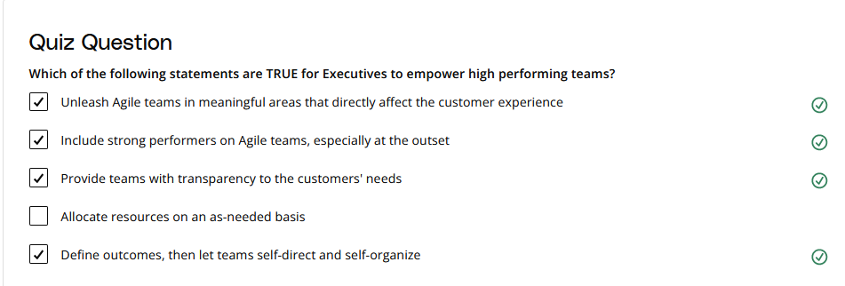

### Quiz Question

TRUE or FALSE: Agile recommends a multidisciplinary way of composing teams that has implications for nearly every business function. True

The Facilitator invites 5 attendees to a ceremony. How many communication channels are there in this meeting? 15

TRUE or FALSE: Agile Governance should mirror the Agile Manifesto principles, particularly the art of simplicity - maximizing the work not done is essential. True

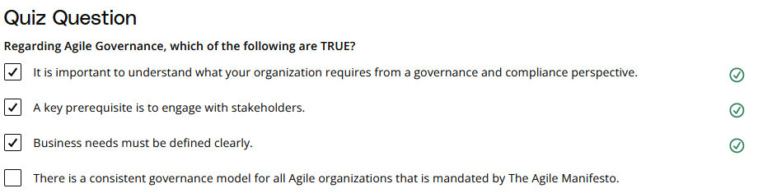

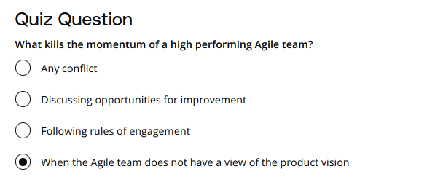

Build and evolve

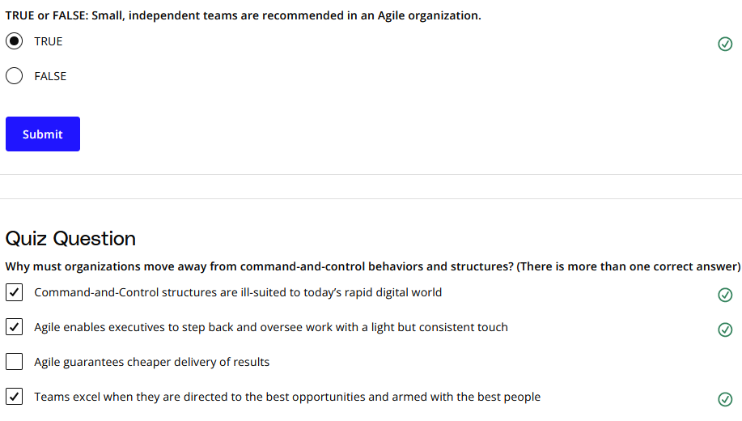

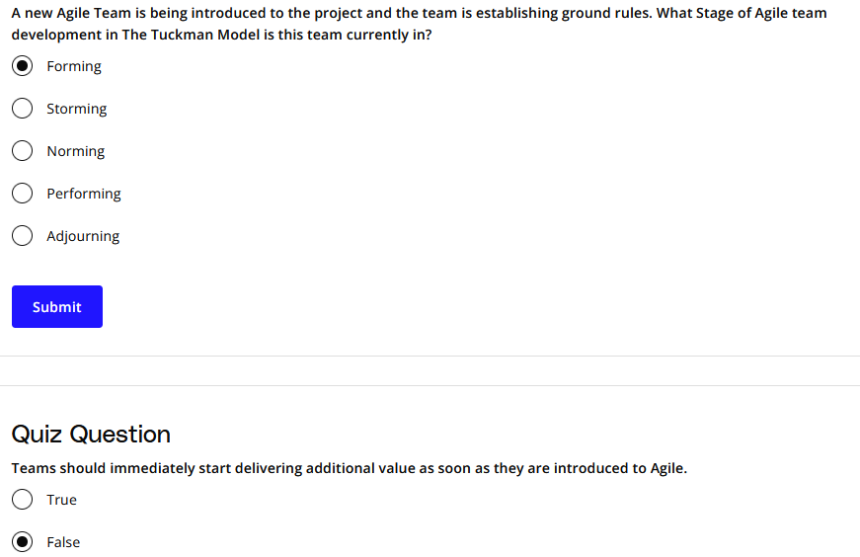

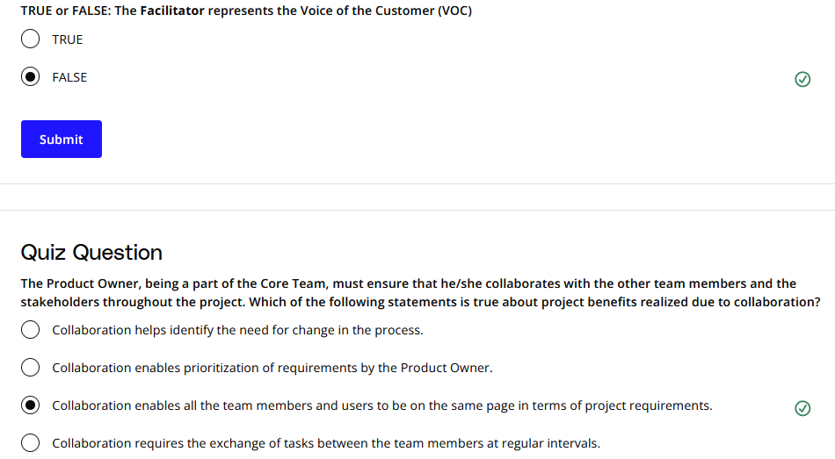

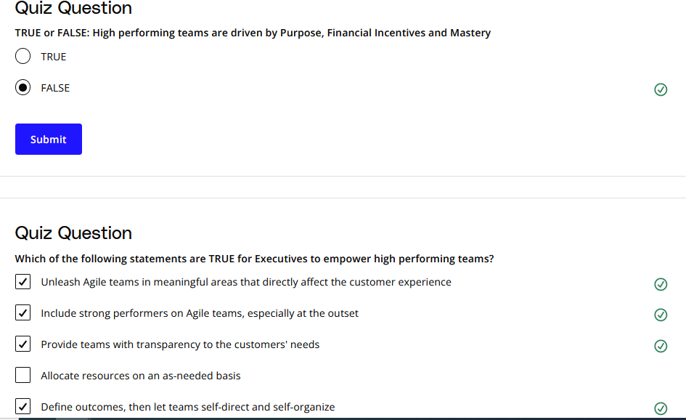

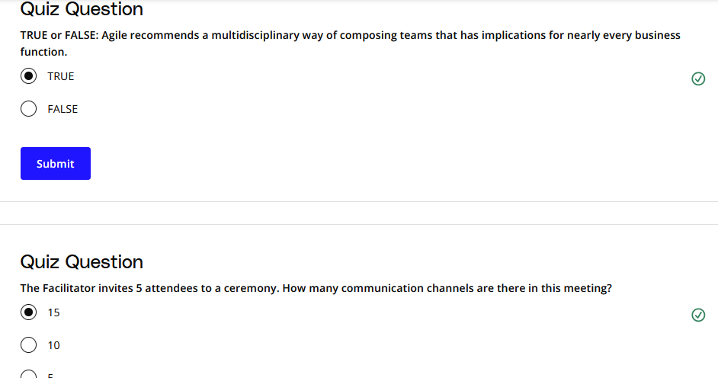

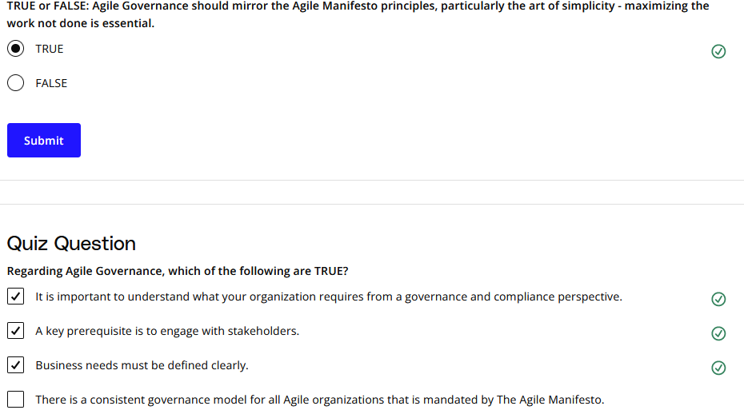

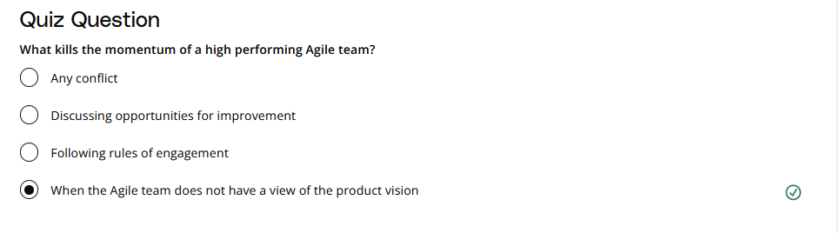

Agile Frameworks promote a highly iterative process for Product Development. True

Agile is designed in a way so all parties can provide feedback as the software is developed in an efficient and effective manner. True

